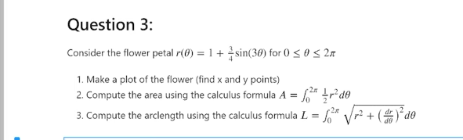

Solution

>>>>>>>

import numpy as np

import matplotlib.pyplot as plt

theta=np.linspace(0,2\*np.pi,1000)

r=1+3/4\*np.sin(3\*theta)

x=r\*np.cos(theta)

y=r\*np.sin(theta)

plt.plot(x,y)

a=sum(1/2\*r\*\*2\*(theta[1]-theta[0]))

print('area is equal to',a)

l=sum(np.sqrt(r\*\*2+np.gradient(r,theta)\*\*2)\*(theta[1]-theta[0]))

print('arc length is =',l)

………………………………………………………………………………….